 CHEMICAL ENGINEERING TRANSACTIONS  VOL. xxx, 2026 | A publication of  
The Italian Association
of Chemical Engineering
Online at www.cetjournal.it

Guest Editors: Flavio Manenti, Botir Usmonov, Alessandro Di Pretoro
Copyright © 2026, AIDIC Servizi S.r.l.
ISBN 979-12-81206-xx-x; ISSN 2283-9216
Reduction Of Hydrodynamic Losses And Cavitation In Pump Aggregates Operating In Abrasive Two-Phase Flows Using Polymer-Modified Coatings
Shomurodov Samandarª, Umar Chorshanbiev^{b*}, Musajonov Mukhammadrasul^{b}, Kurbonov Sultanmurod^{b}, Kuvandikov Kuvonchbek, Suvankulov Akhmad^{b}.
ªTashkent Institute of Chemical Technology, Alisher Navoiy street 32, 100021,Tashkent, Uzbekistan
^{b}Tashkent state transport university, Adilxodjaev street 1, 100157, Tashkent, Uzbekistan
corresponding.author: a.suvonqulov@uzsuv.uz
Pump aggregates operating under aggressive abrasive two-phase flows suffer from erosion, cavitation, and hydrodynamic losses, which significantly reduce efficiency. This study investigates the performance of polymer-modified coatings as a mitigation strategy. The flow was modeled using CFD based on an Euler–Lagrange framework, combining the Navier–Stokes equations for the fluid phase with a discrete phase model for particles. Erosion was evaluated using the Oka model, while cavitation behavior was assessed via the NPSH criterion. Material characterization (UV–Vis, FTIR, SEM) confirmed the formation of a dense polymer network and uniform filler dispersion. Results show that epoxy coatings reduce erosion by 30–40% reduction. Improved surface smoothness decreases the friction factor, reducing hydrodynamic losses and increasing pump efficiency by 10–15%. Additionally, cavitation onset is delayed due to smoother pressure gradients. Overall, polymer-modified coatings provide a combined protective and hydrodynamic optimization effect, offering an effective solution to enhance efficiency and extend the service life of pumps in abrasive environments.
Key words: abrasive two-phase flow, polymer-modified coatings, cavitation, erosion, CFD modelling, hydrodynamic losses, pump efficiency
  - Introduction
Pump aggregates operating in abrasive two-phase flows, particularly in mining and metallurgical processes, are subjected to severe erosion and cavitation, resulting in reduced hydraulic efficiency, increased energy consumption, and higher operating costs. High-velocity particle impacts accelerate wear of the volute and impeller (Oka et al., 2005), while low-pressure regions promote cavitation (Brennen, 2013). Conventional cement-based coatings provide limited protection because their relatively high surface roughness increases hydraulic resistance (Schlichting and Gersten, 2017; Liu et al., 2022), while low elasticity limits impact-energy dissipation (Hutchings, 1992). Previous studies have addressed particle-induced erosion using empirical erosion models (Finnie, 1960) and CFD approaches for analysing multiphase flow structures (White, 2011; Arabnejad et al., 2021). Polymer-based coatings, particularly epoxy and polyurethane systems, have also demonstrated chemical stability, smooth surface formation, and improved erosion resistance (Neville and Wang, 2009; Zhou et al., 2020). However, hydrodynamic processes and coating behaviour are generally investigated separately, and their coupled influence on erosion, cavitation, and hydraulic losses remains insufficiently understood (Zhang et al., 2007). Therefore, this study evaluates polymer-modified coatings for reducing erosion, cavitation, and hydrodynamic losses in centrifugal pumps operating under abrasive two-phase flow conditions. The novelty is the integrated assessment of coating performance through microstructural (SEM), chemical (FTIR), optical (UV–Vis), and hydrodynamic (CFD) analyses, including an epoxy composite based on locally sourced materials (Bakhramov et al., 2022). The approach aims to identify the relationship between coating properties, flow behaviour, erosion resistance, and pump efficiency.
  - Methods and Object
The study investigates a GrAT-type centrifugal pump used for transporting solid-laden hydro-mixtures in copper beneficiation processes, with particular attention to erosion and cavitation at the volute and impeller regions and their mitigation by protective coatings (Babaev et al., 2023). The hydro-mixture was treated as a two-phase system of water and experimentally characterized solid particles (Chorshanbiev et al., 2023). The methodology combined theoretical analysis, CFD modelling, experimental evaluation, and physicomechanical testing to assess flow–material interactions (Jouhara et al., 2016). The protective composite consisted of epoxy resin, a modified amine curing agent, quartz powder, and Angren kaolin. After surface cleaning and preparation to ensure adequate adhesion, the composite was uniformly applied to the erosion-prone volute and impeller surfaces as a 2–4 mm thick layer. Coating thickness and surface smoothness were controlled because they directly affect adhesion, erosion resistance, and hydrodynamic losses. The internal flow was modeled using an Euler–Lagrange approach, with the fluid phase described as a continuous medium by the Navier–Stokes equations:
$ρ(\frac{∂\overset{⃗}{v}}{∂t}+\overset{⃗}{v}⋅\text{∇}\overset{⃗}{v})=-∇p+μ∇^{2}\overset{⃗}{v}$ (1)
The motion of solid particles was determined using the discrete phase model (DPM) and is described by Eq(2):
$m_{p}\frac{d{\overset{⃗}{v}}_{p}}{dt}=F_{D}+F_{g}+F_{other}$ (2)
where $F_{D}$ — drag force, $F_{g}$ — gravitational force.
Turbulence effects were modeled using the realizable k–ε model, which provides improved accuracy for rotating and swirling flows.
The erosion rate was evaluated based on the Oka erosion model (Oka et al., 2005), with consideration of the physicomechanical properties of the polymer coating:
$E=C⋅v^{n}⋅d^{m}⋅\frac{1}{H_{eff}}⋅ϕ(E_{elastic},A_{adh})$ (3)
where $v$ — particle velocity (m/s); $d$ — particle diameter (m); $H_{eff}$ — effective hardness of the coating; $E_{elastic}$ — elastic modulus; $A_{adh}$— adhesion energy.
This approach enables direct consideration of material properties in erosion behavior. Cavitation potential was evaluated using the Net Positive Suction Head (NPSH) criterion:
$NPSH=\frac{p}{ρg}+\frac{v^{2}}{2g}-\frac{p_{v}}{ρg}$ (4)
Low-pressure regions were identified, and the shift in cavitation inception under different coating conditions was analyzed. The numerical simulations were performed using COMSOL Multiphysics within an Euler–Lagrange framework. The continuous hydro-mixture phase was described by the Navier–Stokes equations, while the dispersed solid particles were tracked as a discrete phase. Turbulence was represented using the realizable k–ε model. The inlet boundary was specified according to the operating flow condition of the investigated pump, whereas the outlet was defined by the corresponding pressure condition. A no-slip condition was imposed on the internal solid walls. Solid particles were introduced at the inlet and tracked through the pump domain to identify particle-impact and erosion-prone regions. A structured computational mesh was employed. Mesh sensitivity was evaluated using progressively refined meshes by comparing the predicted velocity and pressure fields. Further refinement resulted in only minor variations in the principal hydraulic parameters; therefore, a mesh containing fewer than 100,000 elements was considered sufficient to provide an appropriate balance between numerical accuracy and computational cost.
  - Result
The results are presented in three stages: characterization of pump operating conditions and hydro-mixture properties, evaluation of the epoxy composite, and CFD analysis of flow, erosion, cavitation and pump efficiency (Table 1).
Table 1: Operating characteristics of pumps used in a copper beneficiation plant
№ | Pump model | m³/h | Head, m | efficiency % | impeller diameter (D) | Power – N, kW | Rotational speed rpm
1 | GrAT 170/40 | 170 | 40 | 60 | 345 | 75 | 1500
2 | GrAT 350/40 | 350 | 40 | 64 | 510 | 132 | 1000
3 | GrAT 1400/40 | 1400 | 40 | 56 | 720 | 500 | 750
4 | GrAT 1600/50 | 1600 | 50 | 69 | 790 | 315 | 725
GrAT 170/40, GrAT 1400/40 and GrAT 1600/50 pumps are used for transporting hydro-mixtures in the investigated plant. During the study, parameters influencing pump erosion were investigated, with particular emphasis on the particle size distribution of the hydro-mixture. Granulometric composition was determined in accordance with GOST 14180-80, GOST 10141-91, and GOST R ISO 5223-99 standards.
Experimental procedures were carried out using a ball mill and a sieve analysis system. Sieve analysis showed that 96.992% of the solid particles were smaller than 0.063 mm, confirming the predominance of a fine dispersed fraction in the investigated hydro-mixture. The results indicate that approximately 97% of the tailings consist of particles smaller than 0.063 mm. Considering that more than 92% of solid particles in the investigated system are below 0.071 mm, the reliability of the experimental approach was confirmed. The chemical composition of the solid phase was determined using a NEX CG analyser (Rigaku Technologies, USA) by the fundamental parameter method (Scatter FP). SiO₂ was the dominant component (33.9 mass%), followed by Al₂O₃ (7.71 mass%), K₂O (2.28 mass%), CaO (2.09 mass%), SO₃ (1.81 mass%), MgO (1.20 mass%), and ZnO (1.49 mass%). The predominance of SiO₂, together with the fine particle-size distribution, confirms the abrasive character of the transported solids and explains the intensive erosive wear observed on the internal pump surfaces. Experimental observations of pump operation showed that, for uncoated metal surfaces, intensive erosion occurs at the volute inlet (mass loss: 0.85–1.1 mg/h), while micro-pitting and crack formation are observed at the impeller outlet. Local perforation was detected after 120–150 hours of operation, accompanied by a reduction in efficiency by 8–12%. In addition, surface micro-defects act as cavitation nuclei, accelerating pitting processes. A cement-based coating, commonly used in practice, was also evaluated. The results indicate that erosion was reduced by 1.8–2.2%, with a corresponding mass loss of 0.7–0.8 mg/h, and the service life increased by 5–9%. However, several drawbacks were identified, including increased surface roughness, higher hydrodynamic resistance, and earlier cavitation onset. Its physicochemical and microstructural properties were subsequently characterized (Capricho, et al 2020).
3.1. Physicochemical and microstructural characterization of the material. The structural, chemical, and optical properties of the epoxy composite coating prepared from locally sourced materials were investigated using UV–Vis spectroscopy, FTIR, and SEM. This integrated approach enabled assessment of coating composition, degree of curing, and microstructural uniformity.
UV–Vis spectroscopic analysis. UV–Vis analysis showed characteristic absorption in the 200–350 nm region, indicating structural stability of the epoxy composite (Figure 2a). FTIR bands at ~3400, ~2920, ~1600 and ~1100 cm⁻¹ correspond to –OH, C–H, aromatic C=C and C–O–C groups, respectively. The decrease of the ~915 cm⁻¹ epoxy band confirms ring opening and formation of a cross-linked polymer network (Figure 2b), contributing to improved mechanical and erosion resistance.
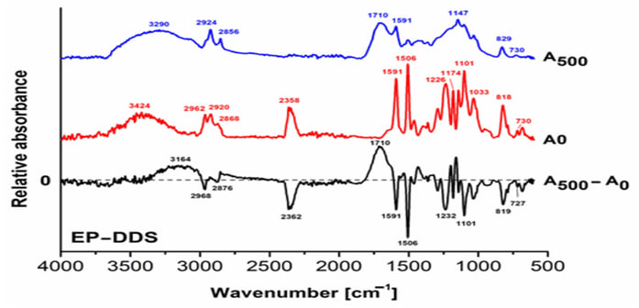 | 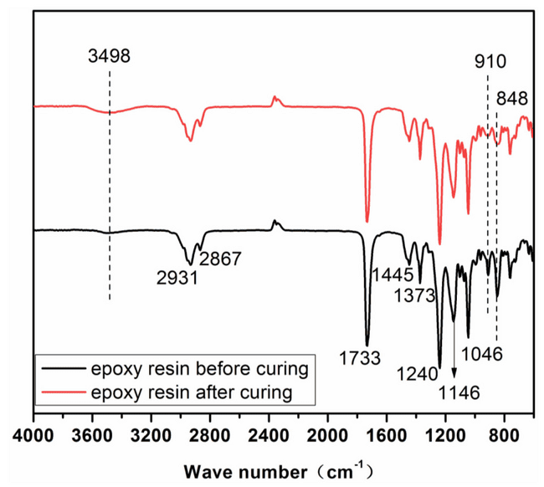
Figure 2: Physicochemical characterization of the epoxy composite coating: (a) UV–Vis absorbance spectrum; (b) FTIR spectrum.
3.1.3. SEM microstructural analysis. SEM images reveal a uniform distribution of filler particles within the epoxy matrix and the formation of a strong interfacial bonding. This stable microstructure reduces localized stress concentrations during particle impact, thereby decreasing erosion rates. The SEM observations are consistent with the low-erosion regions identified by CFD analysis (Figure 3).
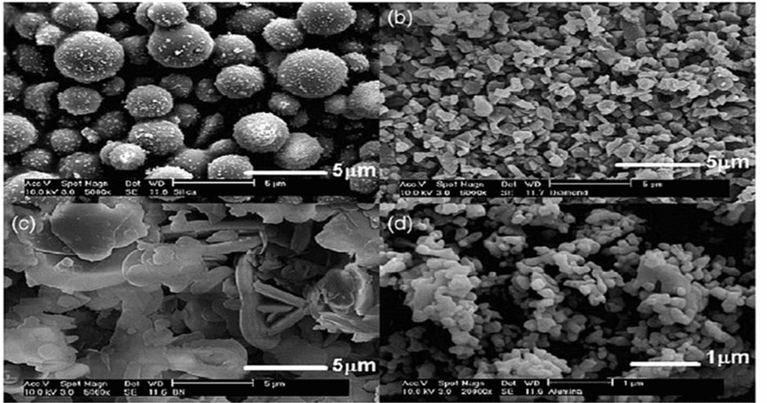
Figure 3: SEM micrographs of the epoxy composite coating at varying magnifications
Figure 4: Epoxy composite preparation and application: (a) mixed high-viscosity composite; (b) epoxy-coated internal surface of the centrifugal pump
The composite exhibits a stable, high-viscosity paste structure, indicating effective dispersion of filler particles within the epoxy matrix. This morphology promotes the formation of a uniform coating layer.
The figure shows the impeller, volute, and cross-section of the coating layer. The smooth and homogeneous coating surface reduces wall friction, lowers turbulence intensity, and consequently decreases hydrodynamic losses. In addition, an adequate coating thickness (2–4 mm) limits direct particle impact on the metal surface, thereby mitigating erosion. The results of the CFD simulations and experimental investigations are presented in Figures 5–8, illustrating the flow structure, erosion behavior, and variations in hydraulic performance within the pump.
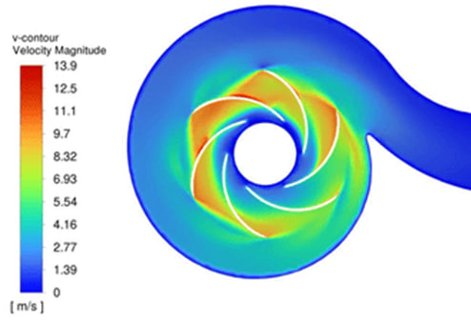 | 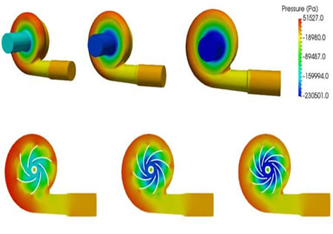
Figure 5: Velocity field distribution in the pump obtained from CFD simulation
The velocity field distribution inside the pump was analyzed (Figure 8).
$Re=\frac{ρvD}{μ}$ (5)
As shown in Figure 6, the flow velocity ranges from 5 to 6 m/s, corresponding to a Reynolds number of Re ≈ (1× 10⁶ for the hydro-mixture. This indicates a fully turbulent flow regime. Under such conditions, wall friction and surface roughness become the dominant factors influencing hydrodynamic losses, highlighting the critical role of coating surface properties.
Figure 6: Erosion distribution within the pump
The distribution of erosion intensity was analyzed, revealing that maximum erosion occurs at the volute inlet and impeller outlet regions (Figure 7). Under turbulent flow conditions, the friction factor (λ) is strongly dependent on surface roughness (ε). Due to the high roughness of concrete coatings, λ increases, leading to elevated hydrodynamic losses:
$λ=\frac{0.25}{{[{log⁡}_{10}(\frac{ε}{3.7D}+\frac{5.74}{Re^{0.9}})]}^{2}}$ (6)
Epoxy coatings enhance surface smoothness, reducing surface roughness (ε) and consequently lowering the friction factor (λ). This results in decreased flow resistance and improved hydraulic efficiency. Compared to uncoated metal surfaces, epoxy coatings reduce erosion by 30–40%, in agreement with experimental mass loss measurements. Pressure distribution and cavitation-prone regions were also evaluated (Figure 9). The minimum pressure is observed at the impeller inlet, identifying it as the primary cavitation region. The application of coatings smooths the pressure gradient and reduces low-pressure zones, thereby delaying cavitation inception.
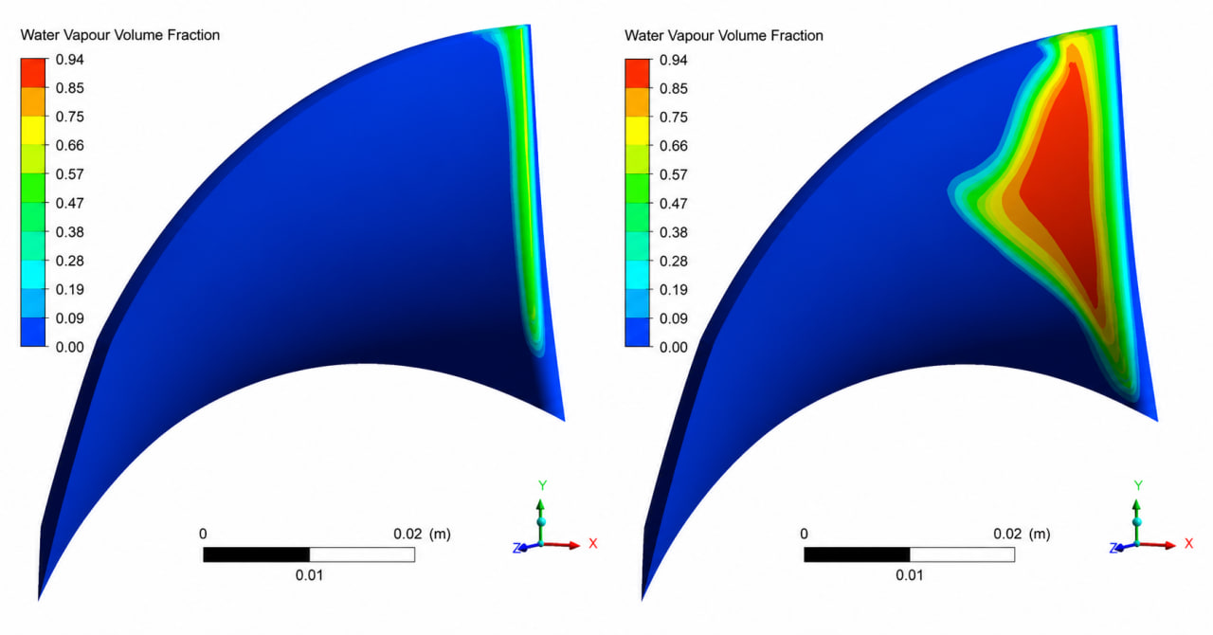
Figure 7: Pressure and cavitation distribution
Pump efficiency was compared across different coating configurations (Figure 8). The efficiency of the uncoated metal surface was approximately η ≈ 0.68, while a decrease was observed with concrete coating. In contrast, the application of epoxy coating increased efficiency to η ≈ 0.74.
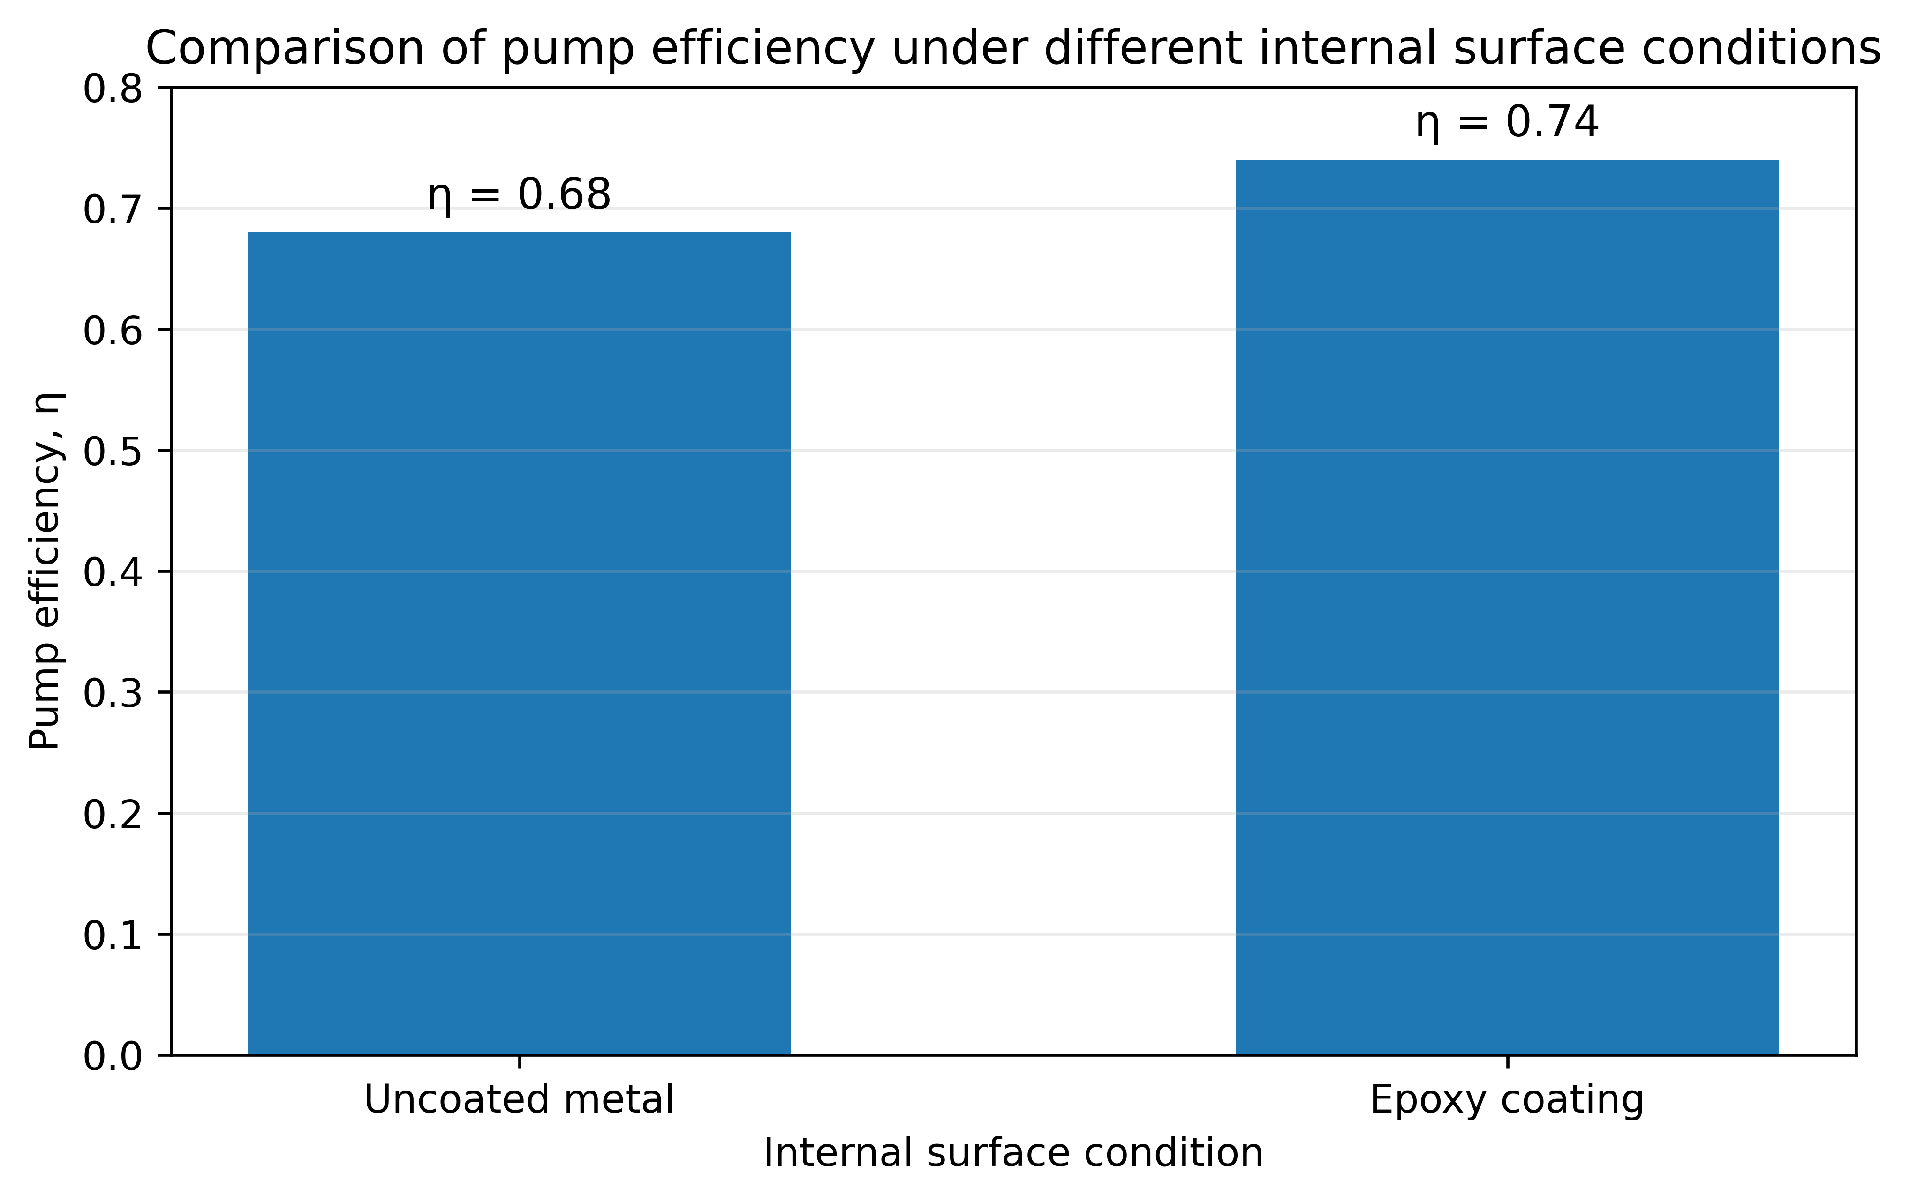
Figure 8: Comparison of pump efficiency under different internal surface conditions
According to the Darcy–Weisbach equation, the hydraulic loss $h_{f}$is directly proportional to the friction factor (λ)..
$h_{f}=λ\frac{L}{D}\frac{v^{2}}{2g}$ (7)
The epoxy coating reduces the friction factor (λ), thereby decreasing hydraulic losses and improving pump efficiency. At Re ≈ 10⁶, the smoother coated surface becomes particularly important because wall roughness strongly influences turbulent hydraulic resistance. The durability results also indicate an advantage of the epoxy composite over the conventional cement-based protection. The cement-based coating provided only a limited improvement in service life under the investigated conditions, whereas the epoxy coating reduced erosion by 30–40%. This reduction indicates a substantially lower rate of coating and substrate degradation. However, the present study did not include a complete long-term service-life test under identical operating conditions; therefore, an absolute service-life ratio between epoxy and cement-based coatings cannot yet be established. Long-term industrial durability testing will be considered in further studies.
  - Discussion
The results demonstrate that coating performance is governed by the coupled effects of material resistance and surface-induced hydrodynamics. Under the fully turbulent conditions observed in the pump (Re ≈ 10⁶), surface roughness strongly influences the friction factor and consequently hydraulic losses. The smoother epoxy surface simultaneously reduces particle-induced erosion and wall resistance, while the more uniform pressure distribution decreases the tendency for cavitation inception. Thus, the polymer coating acts not only as a protective layer but also as a means of hydrodynamic optimization.
  - Conclusion
This study demonstrated the combined protective and hydrodynamic effects of an epoxy composite coating on centrifugal pumps operating with abrasive two-phase flows. At velocities of 5–6 m/s and Re ≈ 10⁶, surface roughness significantly influenced hydraulic losses. The epoxy coating reduced erosion by 30–40%, while its smoother surface decreased flow resistance and increased pump efficiency from approximately 0.68 to 0.74. FTIR, SEM and UV–Vis analyses confirmed a stable cross-linked structure and uniform filler dispersion. CFD results further showed reduced low-pressure regions and delayed cavitation inception. The proposed epoxy composite therefore provides a practical approach for simultaneously improving erosion resistance, hydraulic performance and pump durability.
References
- Arabnejad H., Shirazi S.A., McLaury B.S., 2021, CFD-based erosion prediction in slurry flows considering particle–wall interactions, Wear, 476, 203653.
- Brennen C.E., 2013, Cavitation and Bubble Dynamics, Cambridge University Press, Cambridge, UK.
- Finnie I., 1960, Erosion of surfaces by solid particles, Wear, 3, 87–103.
- Hutchings I.M., 1992, Tribology: Friction and Wear of Engineering Materials, Edward Arnold, London, UK.
- Liu X., Wang Y., Chen H., 2022, Effect of surface roughness on turbulent flow and energy losses in pipeline systems, Chemical Engineering Research and Design, 180, 45–56.
- Neville A., Wang C., 2009, Erosion–corrosion of engineering materials, Wear, 267, 195–203.
- Oka Y., Okamura K., Yoshida T., 2005, Practical estimation of erosion damage caused by solid particle impact, Wear, 259, 95–101.
- Schlichting H., Gersten K., 2017, Boundary-Layer Theory, Springer, Berlin, Germany.
- White F.M., 2011, Fluid Mechanics, McGraw-Hill, New York, USA.
- Zhang Y., Reuterfors E.P., McLaury B.S., Shirazi S.A., 2007, Comparison of erosion models for slurry flows, Wear, 263, 109–117.
- Zhou Y., Zhang J., Liu Y., 2020, Experimental investigation of cavitation erosion resistance of polymer coatings, Surface and Coatings Technology, 385, 125420.
- Kakharov, B. B., Mukhamedgaliev, B. A., Chorshanbiev, U. R., & Makhkamov, U. R. (2023). Development of efficient additives for lubricants from secondary resources. PROBLEMS IN THE TEXTILE AND LIGHT INDUSTRY IN THE CONTEXT OF INTEGRATION OF SCIENCE AND INDUSTRY AND WAYS TO SOLVE THEM:(PTLICISIWS-2022), 2789(1), 040092.
- Bakhramov, U., Kakharov, B. B., & Obidzhonov, A. J. (2022, June). Simulation of consumption processes of a target product in engineering networks. In AIP Conference Proceedings (Vol. 2432, No. 1, p. 030079). AIP Publishing LLC.
- Babaev, A., Teshabaeva, E., Obidjonov, A., & Chorshanbiev, U. (2023). Study of the hydraulic parameters of the flow of solid particles in the process of hydrotransport. In E3S Web of Conferences (Vol. 401, p. 03034). EDP Sciences.
- Jouhara, H., Fadhl, B., & Wrobel, L. C. (2016). Three-dimensional CFD simulation of geyser boiling in a two-phase closed thermosyphon. International Journal of Hydrogen Energy, 41(37), 16463–16476.
- Chorshanbiev, U., Ibadullaev, A., Babaev, A., & Kaxarov, B. (2023). Study of the motion of modified solid particles in hydratransport systems. In E3S Web of Conferences (Vol. 401, p. 03027). EDP Sciences.
- Capricho, J. C., Fox, B., & Hameed, N. (2020, January 2). Multifunctionality in Epoxy Resins. Polymer Reviews. Taylor and Francis Inc.
- Shermukhamedov, U., Abdullaev, A., & Svezhentsev, D. (2025, July). Modeling of stress-strain state of reinforced soil abutments of continuous monolithic road bridge. In AIP Conference Proceedings (Vol. 3256, No. 1, p. 030031). AIP Publishing LLC.

